TIGERS X-C

Thank you for your interest in joining Cross Country for the 2018 season! As many of you may know we have had some very successful seasons of late! Your coaches are very excited to get going on another one!! The following is some information on the upcoming season and some access points for additional information and resources this summer.

The following information is for fist timers joining the team.
- Any and all workouts before the start of school attendance are completely optional.
- Runners will be grouped for workouts based on where they feel they are comfortable at their current level of conditioning.
- There is no bench, runners get what they want to get out of participating in our sport.
- Practices begin with a warm up then stretching and the day’s workout with a cool down to conclude the day.
- Adequate running shoes are the single most important item. Really the only item needed to participate in the sport.
- Please check with the office on current physical status or bring new athletic physical form on day of workout. (Physical and School fees are needed to be in compliance before we are allowed to let you practice-even for optional workouts.-Does not apply for camp)
Please visit our Summer XC website for additional updates this summer. Also some information on summer conditioning and resources for those who want to track their mileage.
Summer XC: https://goo.gl/57oyko
Team XC site: https://goo.gl/QFu07X

2016 Girls Sectional Champions
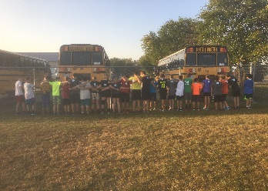
2016 Guys Sectional Runner Up

