 |  |  | Camp is held at
Congratulations Varsity Girls Basketball Team on their 21-9 season record this past year!  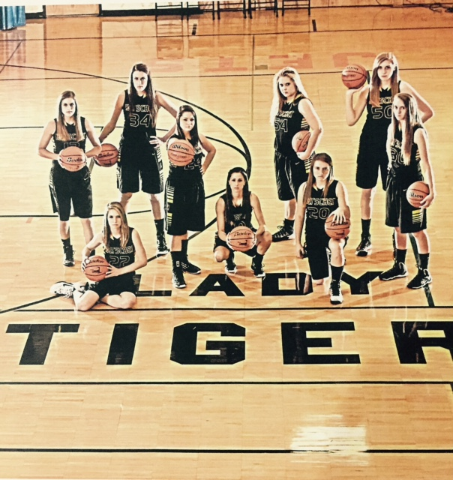  - June 8-11  Herscher Girls Basketball Camp  Purpose of Camp:  To give each girl the opportunity to learn the same offensive skills that are used by the Herscher High school Girls Basketball Team. Each player will receive instruction on shooting, passing, dribbling, and ball handling. Special emphasis will be placed on individual practice. Time will also be spent on concepts of team offense and defense.  HERSCHER GIRLS BASKETBALL CAMP APPLICATION FORM  Name______________________  Address__________________________________  Cell #______________Grade entering:___________  Guardian’s Name____________________________  Shirt Size: Youth – Sm, Med, Lg - Womens - Sm, Med, Lg, XL  My daughter has my permission to participate in the Herscher Girls Basketball Camp.  Guardian Signature: _____________________________________________ |  |  | Limestone Middle School Gym  Entering Grades  8:00-9:15 4, 5, & 6  9:30-10:45 7 & 8  11-1:00 pm 9-12  Tuition Cost:  $40 – Just Youth Camp)  $60 – Youth and Shooting Camp(June 22-24)  Camp features:  T-shirts, Games, Popsicles, and Herscher Tiger Headband  Instructors:  Jennifer Savoie, Nick Arndt, and HHS Girls Basketball Players  Return checks and forms to HHS. Make checks payable to Herscher High School.  

