Tiger Fans!
Come on out Saturday, August 22nd, and get a sneak preview of all our fall teams all in one day! Fans will be able to purchase spirit wear, fall and/or season passes, play cow pie bingo, and enjoy food from the concession stand. Tickets for cow pie bingo are on sale at County West Physical Therapy for $20. First place bingo is $1000, 2nd place $750, and 3rd place $250.
The timeline is as follows:

3:00 p.m./gym | Sophomore/ Freshmen Volleyball Scrimmage
3:30 p.m./gym | Varsity Volleyball Scrimmage
4:00 p.m./outside | Sophomore Soccer Scrimmage
4:30 p.m./outside | Varsity Soccer
5:00 p.m. | Cross Country Team Introduction
5:10 p.m. | Freshman Football Scrimmage
5:30 p.m. | Sophomore Football Scrimmage
6:00 p.m. | Cheerleaders Introduction
6:30 p.m. | Varsity Football Scrimmage
7:00 p.m. | Cow Pie Bingo

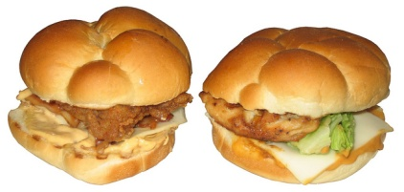
Bingo!

