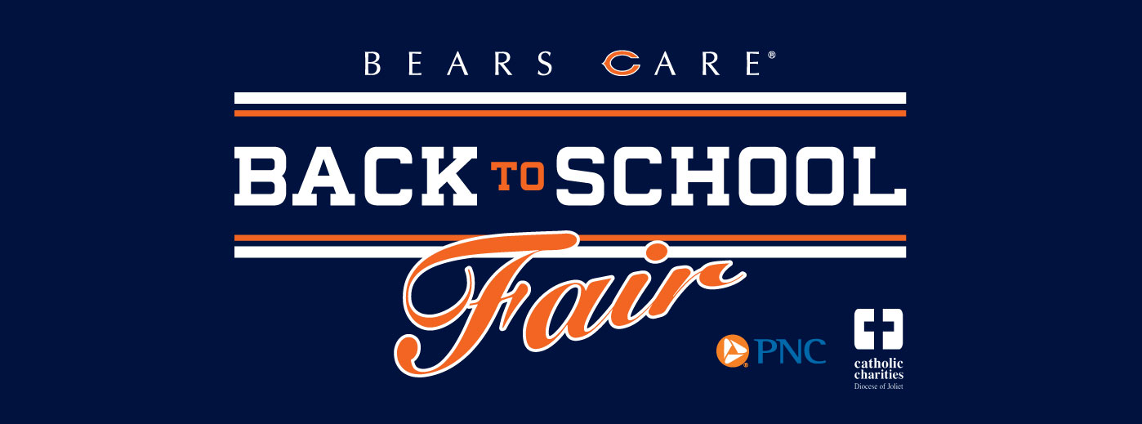

**2016 Catholic Charities’ BACK TO SCHOOL FAIR**

Saturday, July 30, 2016

at Olivet Nazarene University’s Chalfant Hall

**Registration begins June 20, 2016**

Catholic Charities Office, 249 S. Schuyler Ave, Kankakee

8:30am-12:00pm & 1:00pm-3:30pm

PARKING LOT & ENTRANCE IN REAR

**OR REGISTER AT: catholiccharitiesjoliet.org**

Participation is income-based. Please present your driver’s license &

child’s medical card at time of registration. Registration is limited so hurry in!

**Call for questions 815-933-7791 Ext. 9904**

__________________________________________________________________________________________________

**Sponsored by:**



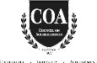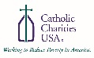

Catholic Charities, Diocese of Joliet is a faith-based organization providing service to people in need and calling others of good will to do the same.